Outer Air Battle Model
Description
This is a model of the traditional Carrier Battle Group (CVBG) “Outer Air Battle” (OAB) defensive arrangement.
This model demonstrates several features of AFSIM, listed below:
- Executing scripts at route waypoints (callback)
- Flying orbits with time limits
- Defining and using global routes
- Creation and deletion of platforms by another platform
- Maintaining related data in a “script_struct” object type
Each of these applications will be described in detail.

Model Overview
OAB was developed by the US Navy in response to the threat to the CVBG of long range bombers carrying anti-ship missiles (ASM’s). Fighter and Airborne Early Warning (AEW) aircraft were flown to defend the CVBG. The fighters would fly CAP (combat air patrol) stations some distance from the CVBG. The AEW aircraft would detect the incoming bombers and vector the fighters to intercept and destroy the bombers. Ideally, the fighters would destroy the bombers before they could fire their ASM’s at the carrier (CV). (This is called shooting the archer.) If that failed, then the fighters would attempt to destroy the individual ASM’s.
The model supports different approaches to OAB. Two example approaches are provided here:
- The first approach establishes medium range CAP (MRC) and Extended Range CAP (ERC) routes. The MRC places aircraft in orbits about 200 NM from the CV. The ERC, despite its name, is actually a long range “out and back” mission. This formation is depicted in Figure 1. (Figure 1 is from the Boeing Carrier Suitability Course, 2009.)
- The second approach establishes MRC and a Long Range CAP (LRC) stations. The LRC stations are 100-200 NM farther out than the MRC stations.
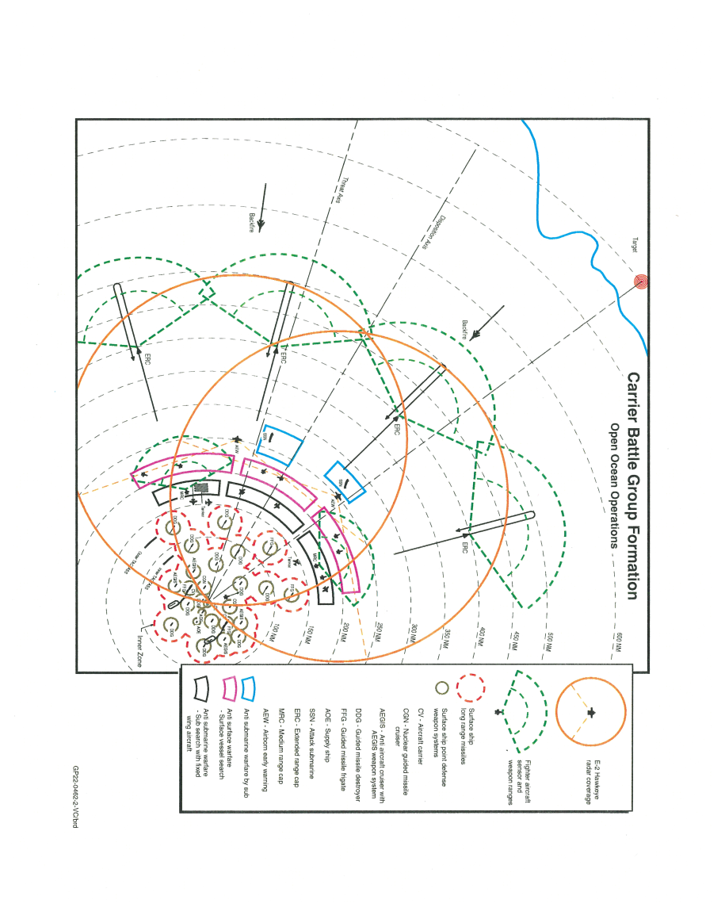
Figure 1 – Open Ocean Operations

Modeling Approach
In this model, the CVN platform creates the CAP fighters and AEW aircraft, which are then assigned to fly along pre-defined global routes. The numbers of each type of aircraft are variables that can be changed by the user. The routes that they will fly are specified using a prefix – the number of each aircraft will be concatenated to determine the specific route.
As an example, if there are two AEW aircraft, and the route prefix is “aew-“, then the CVN will assign the two AEW aircraft to fly routes “aew-1” and “aew-2”. If any expected routes do not exist, then that aircraft will not be flown.
The platforms used in this model are shown in Table 1.

Platform type | Derived from | Purpose
CVN | WSF_PLATFORM | Launches OAB aircraft, based on launch cycle. It also assigns aircraft to intercept threats.
TIMED_AC | WSF_PLATFORM | Flies orbits based on time limits, using the STATION_TIMER script processor
BLUE_PROP_AWACS_1 | TIMED_AC | AEW aircraft with geo-sensor. Reports tracks to commander
BLUE_MULTIROLE_FIGHTER_2 | WSF_PLATFORM | Air-to-air fighter, has radar (geo-sensor), ESM, AAM. Task processor only engages tracks if assigned. Returns to route if target killed.
BLUE_MULTIROLE_FIGHTER_2_ERC | BLUE_MULTIROLE_FIGHTER_2 | Defined as ERC category.
BLUE_MULTIROLE_FIGHTER_2_MRC | BLUE_MULTIROLE_FIGHTER_2 | MRC category, will fly orbits using STATION_TIMER script
BOMBER | WSF_PLATFORM | Target

Table 1 – Model platform types.

The processors used in this model are listed in Table 2 below.

Processor name | Derived from | Platform | Purpose
CVN_TASK_PROCESSOR | WSF_TASK_PROCESSOR | CVN | Launches aircraft and assigns intercepts
BLUE_MULTIROLE_FIGHTER_2_TASK_PROCESSOR | WSF_TASK_PROCESSOR | BLUE_MULTIROLE_FIGHTER_2 | Flies, intercepts and engages targets, if assigned by the CV. Returns to route when finished
STATION_TIMER | WSF_SCRIPT_PROCESSOR | BLUE_MULTIROLE_FIGHTER_2_MRC  TIMED_AC | Flies an orbit until a) time to refuel or b) time to return home. Relies on a call to script “OnStation” to set timers.

Table 2 – Model processors

Calling Scripts in Routes
A platform level script can be called when a platform reaches a waypoint in a route. An example of a platform level script is shown in Figure 2. Lines 13-31 define the script “OnStation”.
Figure 3 shows how scripts can be called when a waypoint is reached. On lines 12 and 20, the platform scripts “OnStation” and “atEndOfRoute” are called, respectively.
Note: if the script does not exist on the platform, nothing will happen. AFSIM will not give an error message, and there will be no indication to the user that anything is missing.
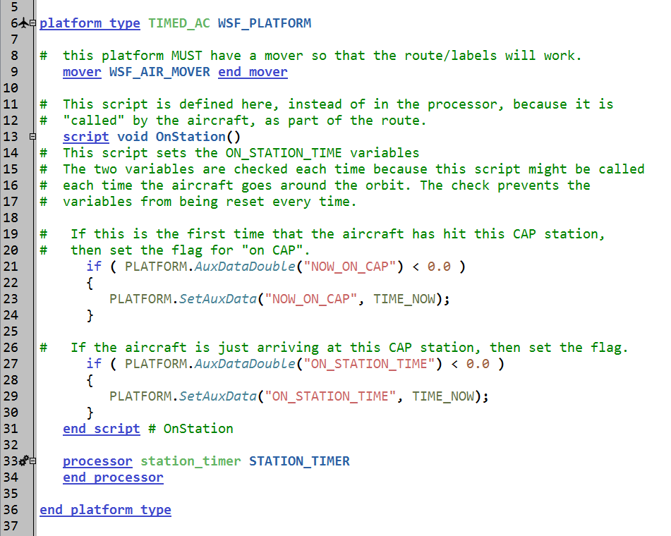
Figure 2 – Platform script example

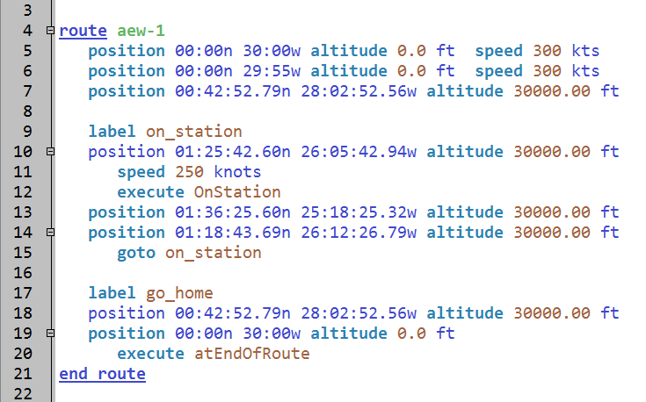
Figure 3 – Route example

Station Timer
This model uses a script processor called “STATION_TIMER”, which enables an aircraft to fly orbits for a set period of time. STATION_TIMER uses the following four variables:
- time_before_refueling – the time on station before the aircraft will fly to the refueling point (default: 1000 seconds)
- total_station_time – the total time on station before the aircraft returns to base (default: 3000 seconds)
- refuel_waypoint_label – the route label for the refueling section of the route (default: “cap_refuel”)
- go_home_waypoint_label – the route label for the return home section of the route (default: “go_home”)
The default values can be changed, either in the specific platform type definition, or in the platform instantiation.
For STATION_TIMER to work, the route MUST have certain characteristics. When the aircraft begins its orbit, that waypoint must contain a call to a platform level script called OnStation. This script sets the timers for the orbit and total station times.
If the aircraft will be refueling, then the route must have a label for the point or points associated with refueling. The refueling section of the route must return to the orbit.
When the aircraft hits its refueling timer, it will fly the “cap_refuel” part of the route, and then return to the orbit. The return to orbit must call OnStation to reset the refuel timer.
When the aircraft reaches its total station time limit, then it will fly the section of the route that takes it back home.
STATION_TIMER is a simple timer. It does no other checks. It is the responsibility of the user to make the timing “make sense”. For example, consider a case with following values specified: orbit time limit is 75 minutes and total station time is 100 minutes. Further, assume that the aircraft takes 20 minutes to refuel. In this case, the aircraft will stop orbiting after 75 minutes, and go to refuel. It will return to its orbit at 95 minutes. Five minutes later, at time 100, it will then turn to go home.
An example of a route that uses STATION_TIMER is shown in Figure 4. Lines 137-140 are the beginning point of the orbit. Line 140 calls OnStation to start the timers. Lines 143-145 are the end of the orbit, which loops back to the first point in the orbit.
Lines 133-135 are the refueling point, which leads directly back into the orbit. The label on line 147 enables the aircraft to return home at the end of its total station time.

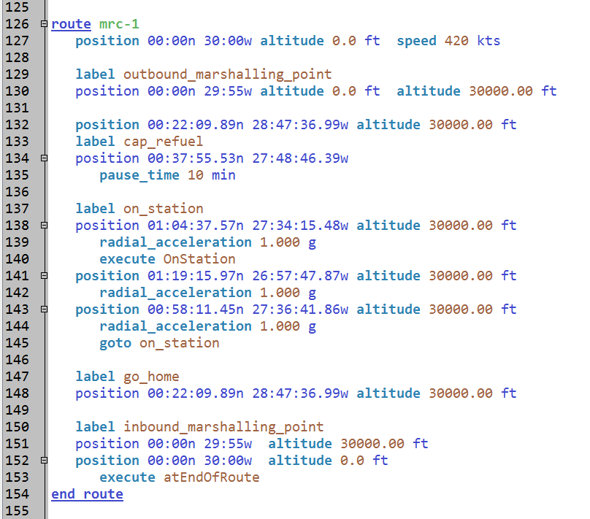
Figure 4 – STATION_TIMER route example

Global Routes
This model uses global routes for the aircraft created by the carrier. A global route is a route that is not defined inside of a platform instantiation. Examples of global routes are shown in Figures 3 and 4.
Global routes can be edited in the Wizard Map Display, but they must be associated with a platform. An example of this association is shown in Figure 5.
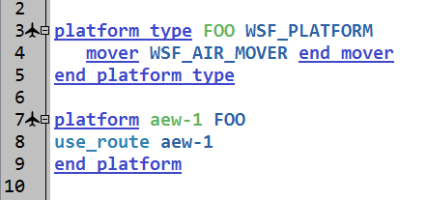
Figure 5 – Association of global routes with platforms

However, since the OAB model creates the platforms during model execution, and then assigns routes to the platforms, they are not explicitly associated with a platform, and therefore cannot be edited in Wizard Map Display. To address this, there is a scenario in the route_edit.txt file that has a set of platforms, one for each global route.
With this association established, the route can be edited in the Wizard Map Display, enabling the user to add, delete and move points on the route.

Platform Creation / Deletion
The CV creates platforms, based on the launch cycle specified. The type and number of each aircraft created are specified as script variables. Each aircraft created is assigned to a global route. If the global route is not valid, then that aircraft is deleted and an error message displayed. The aircraft are then told to fly the specified route.
The mover for each created aircraft is assumed to have “at_end_of_path remove” specified in the mover. If this is not the case, then a callback to a script on the platform must be used to delete the platform. This approach is demonstrated with the FA-18_ERC platforms.

struct data structure
The AFSIM scripting language provides a mechanism that enables the user to aggregate several pieces of data together. From the AFSIM Documentation, the “struct” is a basic type that allows for custom objects. In computer science terms, it is a mechanism for creating and using a “record”.
In this model, the data specifying the types and quantities of the aircraft are stored together in a struct type called “launchParameters”, which is defined at the global level. This structure is shown in Figure 6. This record contains three items, an integer variable and two string variables.

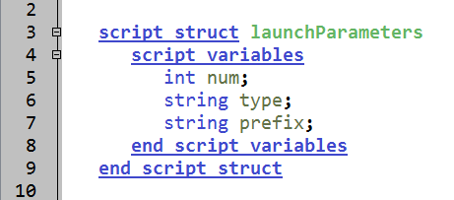
Figure 6 – Script struct “launchParameters”

Figure 7 shows how specific instances of this structure are created, and how values are assigned to the parts of the structure. Line 34 creates the new structure “ERC”. Lines 35-37 assign values to the elements in ERC. Notice the use of the arrow operator to indicate which element is being referenced. Lines 38-45 repeat the process for two additional structures.

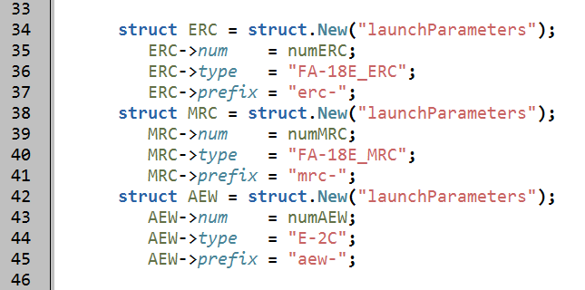
Figure 7 – Creation and initialization of structures

With specific structs created with values, the script can use those values. For example, the ERC struct contains the values for the extended range CAP aircraft. In Figure 8, line 201 shows how the ERC struct can be used to call the script that creates these aircraft. Figure 9 shows how the parameter is defined in the script definition. Line 54 shows the script definition, and line 55 shows one of the values in the struct being used in the script (tempParms->num).

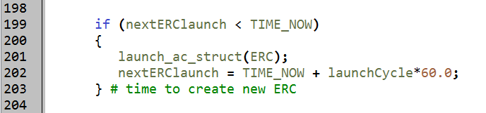
Figure 8 – Calling a script with a structure as input parameter

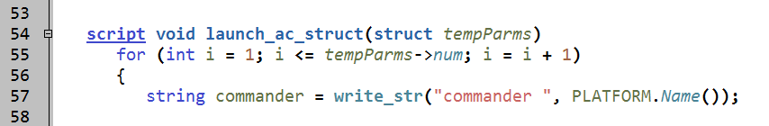
Figure 9 – Use of structure as parameter in a script

Limitations
While this model does contain a provision for launching the aircraft from the carrier on a regular basis, it does not consider the entirety of the carrier deck cycle. Likewise, it does not explicitly consider marshalling of aircraft during recovery. It is assumed that these factors will be included in the global routes.

